TECHNICAL DATASHEET

Product Details

Make : SUDEEP
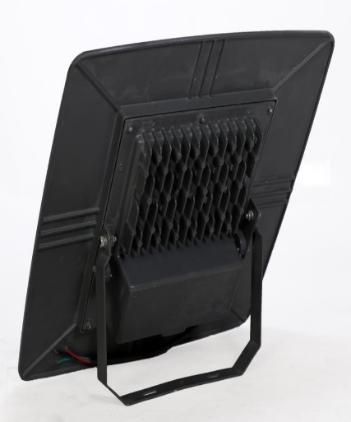
Model : SEHBLW80
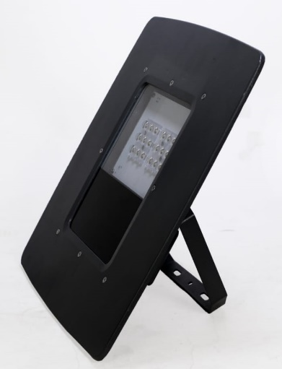
Series : LED Canopy Light
BIS CRS No. : R-71028037

Electrical Data

Input Voltage Range : 90 - 300 VAC
Power : 80 Watt
Power Factor : >0.95
Frequency : 50/60 Hz
Protections : THD < 10%
Driver : Constant Current Active
Power Factor Corrected
Lumens O/P : >9700 Lm

Light Data

Luminaire Efficacy : >120 lm/Watt
LED Efficacy : >150 lm/Watt
Beam Angle : >80 ⁰
CCT : 5700 K +/- 100
Environmental

Voltage Range : 120 to 270 Volts
Working temperature : -10 to +50 Deg. Cel.
Working humidity : 10 to 95%
IP rating : IP66
Protection : IK07
Surge Protection : 5KV (Internal & External),

CRI : >70
LED Make : Osram
LED Type : SMD 2835
LED Life Time : 50,000 hours

Size

L x H x W : 370 x 370 x 65 mm
Warranty : 2 Years
Body Colours : Grey/White

Applications

Manufacturing Plants, Shop Floor, Industrial Areas, Godown, Shops, Warehouses, Storage Units




